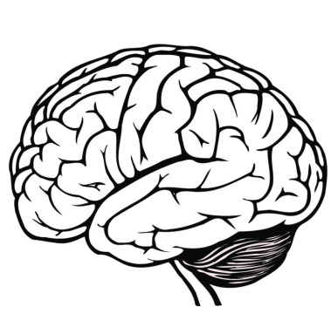
Psychology
Mr. Ruleaux
2018

Welcome to Psychology! During this course, we will examine human behavior and mental processes. Student will participate in multiple experiments and activities that will allow them to replicate and understand how the human mind works.

Text:
Psychology
- Houghton Mifflin Harcourt
Understanding Psychology
- Glencoe McGraw Hill

Materials:
Pencil/Pen
Notebook/paper

Grades:
- Grades will be taken on assignments and tests.
  - Assignments – small essays, group work, worksheets, projects, quizzes, study guides/hearings
  - Tests – Chapter/Unit Tests
- Grade Percentage:
  - Assignments = 40%
  - Tests = 60%

Course Outline:
- History of Psychology
- Psychological Methods
- The Nervous System
- Sensation and Perception
- Consciousness
- Learning/Memory
- Intelligence
- Development
- Personality
- Health

Ruleaux’s Rules:
1. Be on Time
2. Be Prepared
3. Be Respectful
4. All other school rules are in effect

Contact Information:
- eruleaux@esu2.org
- Yutan Public Schools: 402-625-2243
- Available During 4th period:
10:44-11:33

