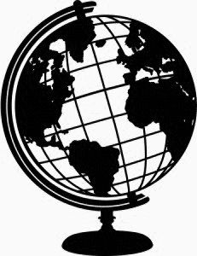
World History
Mr. Ruleaux
2017-2018

Welcome to World History! Students will explore the origins of civilization around the world. We will examine these civilizations’ independence and their interdependence as they rise and fall through ancient times to present day. As we go, we will identify and discuss world religions. In addition, students will identify impactful persons throughout world history.

Text:
World History
- By Houghton Mifflin Harcourt
Glencoe World History: Modern Times

Materials:
3-Ring Binder
Pencil/Pen
Notebook Paper

Grades:
- Grades will be taken on assignments and tests.
  - Assignments –vocabulary assignments, small essays, group work, worksheets, projects, quizzes, study guides
  - Tests – Chapter/Unit Tests
- Point System: grades will be determined by taking your total points divided by the total points possible.
- Tests will have higher point values than most assignments.

Course Topics (Can Be Subject to Change)
- Beginnings of World History
- First Civilizations
- Early Religions: Hindu/Buddhism/Judaism
- Early Empires of Africa and Asia
- Classical Greece
- Roman World/Early Christianity
- Asian Empires
- Middle Ages
- American Civilizations
- Renaissance
- Reformation
- Exploration and Expansion
- Absolute Monarchs
- Enlightenment and Revolutions
- Industrial Revolution
- Imperialism
- WWI
- WWII
- Cold War Conflicts

Ruleaux’s Rules:
1. Be on Time
2. Be Prepared
3. Be Respectful
4. All other school rules are in effect

Contact Information:
Email: eruleaux@esu2.org
Availability: 5th Period, 12:03-12:51

